

American International University-Bangladesh (AIUB)  
**Department of Computer Science  
Faculty of Science &Technology (FST)  
Fall 22-23**

**Section: E  
Group No: 9**

**Food Cycle**

A software Engineering project submitted By

|  |  |  |  |  |
| --- | --- | --- | --- | --- |
| S/N | Student Name | Student ID | Contribution (%) | Individual Marks |
| 1 | Rashid, MD. All Masud Or | 20-43131-1 | 25% |  |
| 2 | Rashique Habib Chowdhury | 20-42269-1 | 25% |  |
| 3 | Lima, Rashida Begum | 20-44095-2 | 25% |  |
| 4 | Emon, MD. Mahadi Hasan | 20-43099-1 | 25% |  |

The project will be Evaluated for the following Course Outcomes

|  |  |
| --- | --- |
| Your Project will be Evaluated based on the following marking criteria | Total Marks |
|  |
| Requirements Analysis (functional, quality, and project requirements) [5Marks] |  |
| System Design (UI/UX design) & Test case [5Marks] |  |
| Project Management Planning [5Marks] |  |
| Submission, Completeness, Spelling, Grammar and Organization [5Marks] |  |

Submission Date:16th of December, 2022

Description of Student’s Contribution in the Project work

|  |
| --- |
| Student Name: Rashique Habib Chowdhury  Student ID: 20-42269-1  Contribution in Percentage (%): 25%  Contribution in the Project:   * Contribution Description 1 Risk Analysis * Contribution Description 2   ________Rashique_______  Signature of the Student |
| Student Name: Rashid, MD. All Masud Or  Student ID: 20-43131-1  Contribution in Percentage (%): 25%  Contribution in the Project:   * Contribution Description 1 Project Management plan * Contribution Description 2   _______Rashid_________  Signature of the Student |
| Student Name: Lima, Rashida Begum  Student ID: 20-44095-2  Contribution in Percentage (%): 25%  Contribution in the Project:   * Contribution Description 1 UI/UX design * Contribution Description 2   _________Lima_________  Signature of the Student |
| Student Name: Emon, MD. Mahadi Hasan  Student ID: 20-43099-1  Contribution in Percentage (%): 25%  Contribution in the Project:   * Contribution Description 1 System test plan * Contribution Description 2   ______Emon___________  Signature of the Student |

# PRODUCT AND PROJECT DESCRIPTION

**Functional Requirement:**

1.Registration

2. Login

3. Food categories

4. Suggestion box

5. Quantity Calculator

6. Inform worker

7. order list

8. Food necessities

9. Logout.

10. Submit.

**System Quality Attributes:**

1. Availability
2. Performance
3. Efficiency
4. Integrity
5. Reusability
6. Reliability
7. Robustness
8. Usability,
9. Testability.

**Functional Requirement:**

**Registration:**

1.New food donor shall be able to register with their valid email id or phone number along with password.

2.Register donor will include systems database.

3.If the registration successful the home page of the user account will be displayed successfully registered.

4.If the email id and/or phone number has been inserted wrong, then display invalid email or phone number.

**Priority Level:** High **Precondition:** user have valid email account or phone number.   
**Cross-references:** NA

**Suggestion box:**

1.The software shall allow users to give feedback after login their account.

2.User will able to select suggestion box then can write their opinion.

3.If complete their write there will submit button to submit it.

4. If submission Successfully will display successful submission.

5.If any problem arise will display try again after sometimes.

**Priority Level:** Low **Precondition:** user have to login in valid account.  
**Cross-references:** 1,2

**Availability:**

The system shall be available at least 90% on week days between 6 am to midnight local time and

at least 95% available on week days between 10 am to 2 pm

**Priority Level:** High

**Precondition:** User should login into the system.

**Cross-references:** QA6, QA7

**Integrity:**

Only admin have access in total system along with registration list.

**Priority Level:** High

**Precondition**: Admin should login along with valid user name and password

**Cross-references:** QA3, QA4, QA8, QA9.

**Project Requirement:**

**1.Time**: We require Seven months to build the software

**2 Budget** :

**3.Resource:** We have to need two human resources to build the software

**4.Environment:** web Application.

# SYSTEM DESIGN SPECIFICATION

## UI/UX Design:

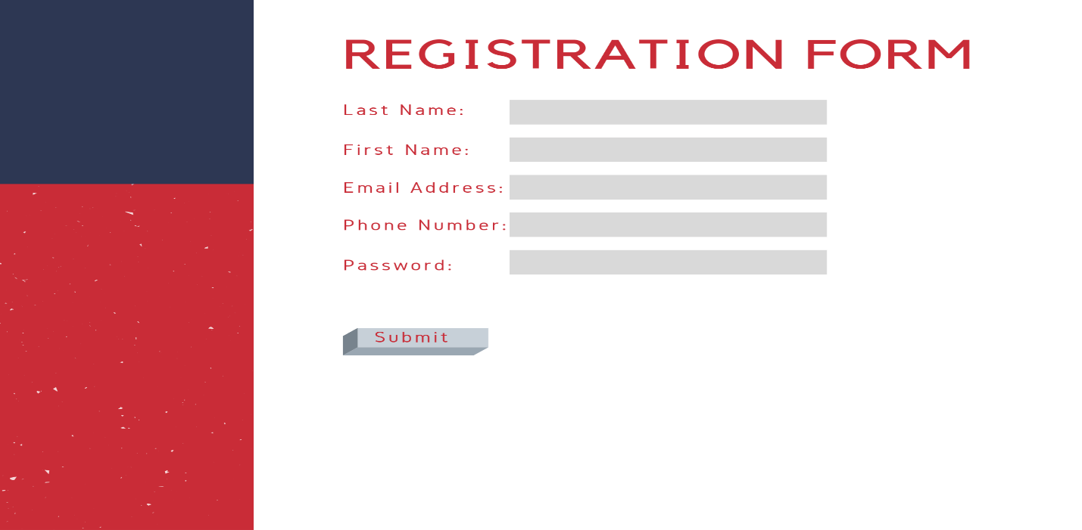

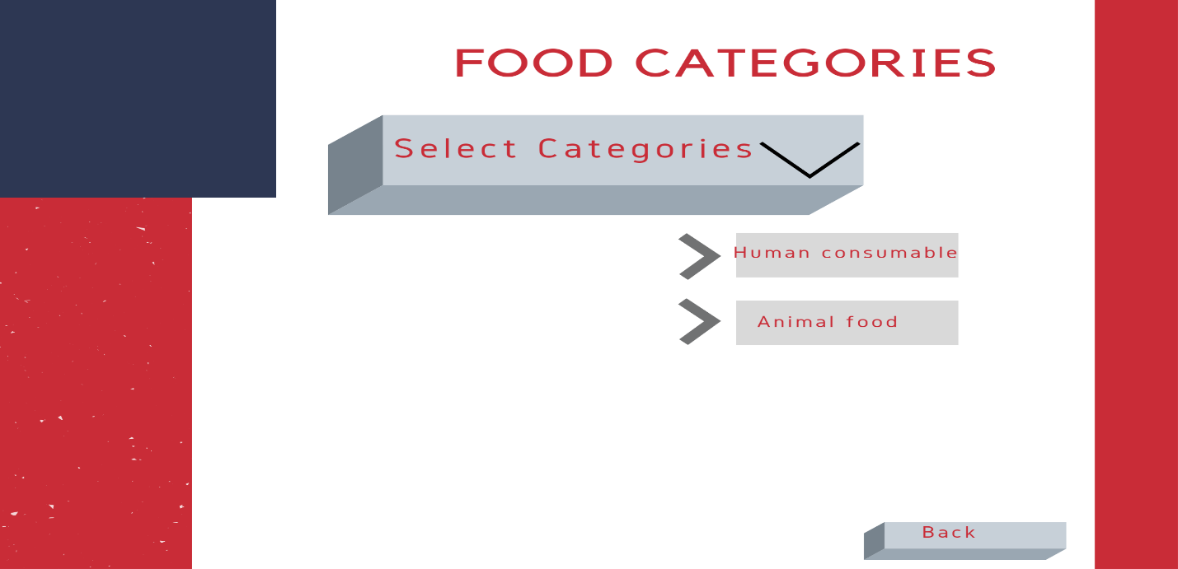

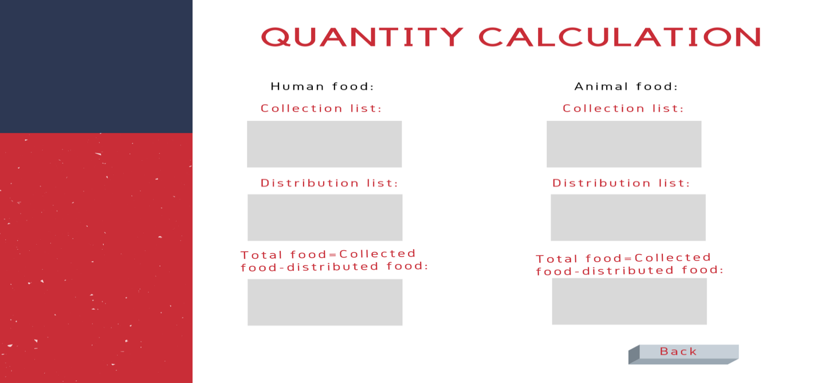

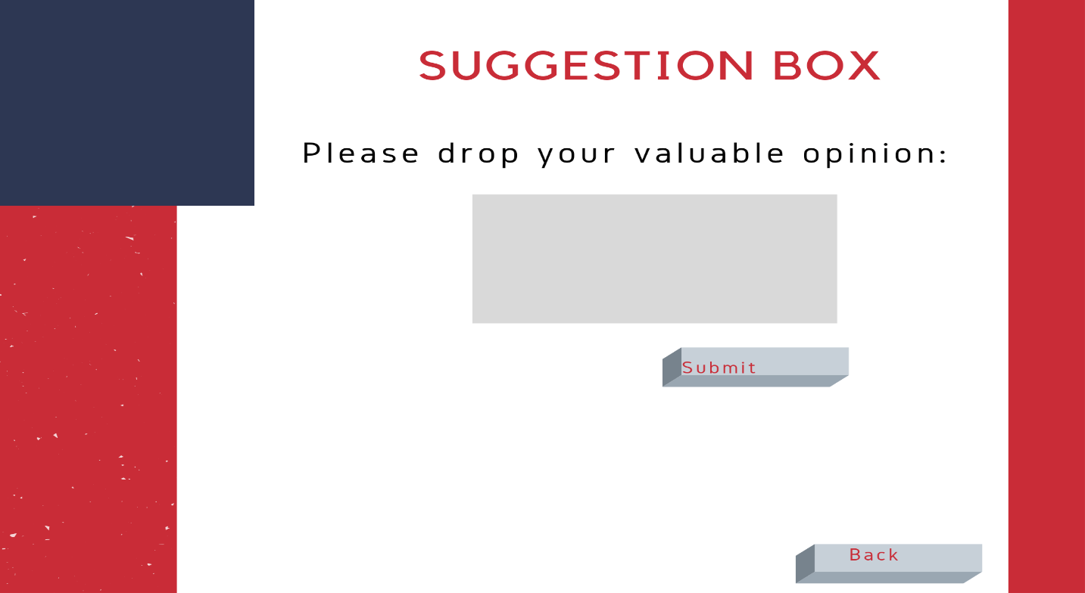

# SYSTEM TEST PLAN

**Registration:**

|  |  |  |  |  |  |
| --- | --- | --- | --- | --- | --- |
| Project Name: Food Cycle | | | Test Designed by: Rashique | | |
| Test Case ID: FR_1 | | | Test Designed date: 01/12/22 | | |
| Test Priority (Low, Medium, High): High | | | Test Executed by: | | |
| Module Name: User Registration Session | | | Test Execution date: | | |
| Test Title: Confirm registration with valid name, email and phone number | | | | | |
| Description: Test website registration page | | | | | |
| Precondition (If any): User must have valid Email and Phone Number | | | | | |
| Test Steps | Test Data | Expected Results | | Actual Results | Status (Pass/Fail) |
| 1. Go to the website 2. Enter username 3. Enter email address 4. Enter phone number 5. Click submit | Username: John  Email: john017@gmail.com  Phone: 01741 | User should register into the application | | As expected, | Pass |
| Post Condition: User is validated with database and successfully register to account. The account session details are logged in the database. | | | | | |

**Suggestion Box:**

|  |  |  |  |  |  |
| --- | --- | --- | --- | --- | --- |
| Project Name: Food Cycle. | | | Test Designed by: Rashid | | |
| Test Case ID: FR_2 | | | Test Designed date: 01/12/22 | | |
| Test Priority (Low, Medium, High): Low | | | Test Executed by: | | |
| Module Name: User Suggestion box Session | | | Test Execution date: | | |
| Test Title: Get user suggestions. | | | | | |
| Description: Test user suggestion box. | | | | | |
| Precondition (If any): User must have register account also should login with valid email or phone number along with password. | | | | | |
| Test Steps | Test Data | Expected Results | | Actual Results | Status (Pass/Fail) |
| 1. Go to the website 2. Log into your account 3. Enter Suggestion box 4. Write suggestion. 5. Click submit | Username: Jack  Email: jacksparrow@gmail.com  Phone: 01234 | User should submit their suggestion. | | As expected, | Pass |
| Post Condition: User is validated with database and successfully submit suggestions. The account session details are logged in the database. | | | | | |
|  | | | | | |

|  |  |  |  |  |
| --- | --- | --- | --- | --- |
| Precondition (If any): User must have valid Email and Phone Number | | | | |
| Test Steps | Test Data | Expected Results | Actual Results | Status (Pass/Fail) |
| 1. Go to the website 2. Enter username 3. Enter email address 4. Enter phone number 5. Click submit | Username: Antony  Email: anto19@gmail.com  Phone: 015677 | User should register into the application | As expected, | Pass |
| Post Condition: User is validated with database and successfully register to account. The account session details are logged in the database. | | | | |

**Food categories:**

|  |  |  |  |  |  |
| --- | --- | --- | --- | --- | --- |
| Project Name: Food Cycle | | | Test Designed by: Lima | | |
| Test Case ID: FR_3 | | | Test Designed date: 01/12/22 | | |
| Test Priority (Low, Medium, High): Medium | | | Test Executed by: | | |
| Module Name: Food category Session | | | Test Execution date: | | |
| Test Title: Show food categories. | | | | | |
| Description: Test website food categories page. | | | | | |
| Precondition (If any): User must have login | | | | | |
| Test Steps | Test Data | Expected Results | | Actual Results | Status (Pass/Fail) |
| 1. Go to the website 2. Log into your Account 3. Enter food categories | Username:  Email:grealish21@gmail.com  Phone: 01234 | User should look after food categories. | | As expected, | Pass |
| Post Condition: User is validated with database and successfully look after food categories. The account session details are logged in the database. | | | | | |

# PROJECT MANAGEMENT PLAN

A project plan as a bar chart

|  |  |  |  |  |  |  |  |
| --- | --- | --- | --- | --- | --- | --- | --- |
| Month  Task: Person | 1 | 2 | 3 | 4 | 5 | 6 | 7 |
| A: Babar |  |  |  |  |  |  |  |
| B: Azam |  |  |  |  |  |  |  |
| C: Babar |  |  |  |  |  |  |  |
| D: Azam |  |  |  |  |  |  |  |
| E: Babar |  |  |  |  |  |  |  |
| F. Azam |  |  |  |  |  |  |  |
| G: Babar |  |  |  |  |  |  |  |

|  |  |
| --- | --- |
| Activity key:  A: Plan  B: Analysis  C: Design  D: Development  E: Testing  F: Deployment  G: Maintenance |  |

**COCOMO (CONSTRUCTIVE COST MODEL)**

Project Type : Organic

Coefficient<Effort Factor> : 2.4 [P= 1.05, T = 0.38]

Source Lines of Code (SLOC) = 5000 Lines

Person Months (PM) = Coefficient<Effort Factor>*(SLOC / 1000)P

= (2.4 *51.05)

= 13.006

Development Time (DM) = (2.5*13.0060.38)

= 6.627

= 7 Months

= 1232 Working Hour

Required People (ST) = PM/DM

= 1.858

= 2 People

**Budgeting:**

**Developer Salary in 7 Months:**

                         Per Developer Salary Per Working Hour = 400 Taka

                         Total Developer Salary                               = 400 *  1232 Taka

                                                                                                = **4,92,800 Taka**

**Requirement Analysis:**

                        Time Needed: 1/2 month (11 Working Days  = 88 Working Hour)

                        Requirement Analysis Person’s Hourly Wage = 300 Taka

                        Total Requirement Analysis Expense                = 300 * 88 Taka

                                                                                                         = **26,400 Taka**

**Transportation Cost Estimation:**

**7,000 Taka**

**Training & Hardware Expenses Estimation:**

**50,000 Taka**

**Rent Expenses:**

                        Room Per Month  = 5,000 Taka

                        Total in 7 Months = **35,000 Taka**

**Total Utilities in 7 Months:**

**21,000 Taka**

**Maintenance (Till 2 Months after Delivery):**

                        Expense Per Hour                                                     = 600 Taka

                        Total Estimated Time Needed for Maintenance = 20 Hours

                        Total Estimated Maintenance Expense                = 20 * 600 Taka

                                                                                                             = **12,000 Taka**

**Total Estimated Expense:**

                        4,92,800 + 26,400 + 7,000 + 50,000 + 35,000 + 21,000 = **6,32,200 Taka**

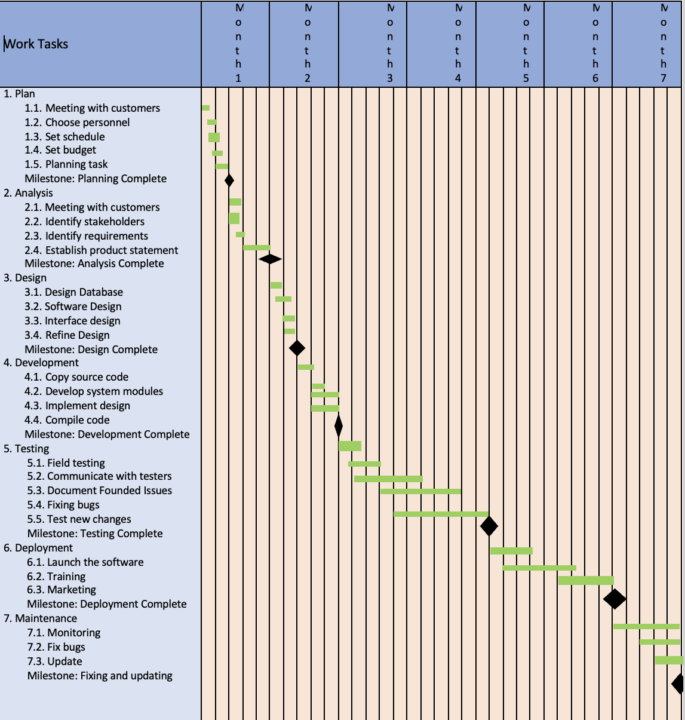

## Risk Analysis

|  |  |  |  |  |
| --- | --- | --- | --- | --- |
| * **S/N** | **Risk Description** | **Probability** | **Impact** | **Mitigation Plan** |
| 1 | Size estimation could be significantly low | 60% | Critical | Sizing by analogy |
| 2 | Greater than anticipated user base. | 30% | Marginal | Conducting focus groups to gather information about users. |
| 3 | Fewer reuse than planned | 70% | Critical | Maintain High Cohesion and modularization. |
| 4 | End-users resist system | 40% | Marginal | Establishing user support services |
| 5 | There will be a tighter delivery deadline | 50% | Critical | Plan Regular Schedule Reviews. |
| 6 | Finances can be misplaced | 40% | Marginal | Uphold the level of ambiguity about the project's budget. |
| 7 | Clients may alter their requirements | 80% | Critical | Change control, incremental development. |
| 8 | Technology will not fulfill expectations | 30% | Catastrophic | Benchmarking, inspections, formal specifications, contractual agreements and quality controls |
| 9 | Insufficient tool training | 80% | Marginal | Give brief, straightforward evaluations top attention. Employees can instantly get feedback on their learning progress because of this. |
| 10 | Incompetent Staff | 30% | Negligible | Hiring the best employees. |